Overview of Reports

Results Suite

Appalachian State University
UNC System Employee Engagement Survey
Spring 2022

Prepared by:

2 Mill Road, Suite 102 | Wilmington, DE 19806
Phone: 888.684.4658 | Fax: 888.684.4659
www.modernthink.com
© 2022 ModernThink LLC. All rights reserved.

Appalachian State University Survey Reports

Your Results Suite includes the following:

- Three Sets of Survey Data Spreadsheets
- General Demographics
- Job Role
- Organizational Level
- Profile of Survey Respondents
- Response Distribution Report sorted by Pre-loaded Employee Group
- Overall Benchmark ScoreCard
- Multi-Select Report
- Topline Survey Results
- Employee Comments Report sorted by Pre-loaded UNC Job Category

Survey Response Rates

The enclosed reports were generated from the data collected from Appalachian State University during the 2022 UNC System Employee Engagement Survey, conducted March 28 to April 18, 2022. To support longitudinal analysis over the course of the five-year project, the System Office will receive aggregate system-wide results for only a core population of faculty and staff. The core population, defined by the System Office, includes all permanent, full-time faculty and staff in the following Pre-loaded UNC Job Categories:

Core Population

- EHRA Non-faculty (NF)
- SAAO Tier 1
- SAAO Tier 2
- EHRA IRPS
- SHRA
- SHRA Exempt
- SHRA Non-exempt
- Faculty

Core Population Response Rates

 | EHRA Non-Faculty |  |  | SHRA |  |  | Faculty |  |  | Total Core Population
Institution | Total Sent | Responded | Response Rate | Total Sent | Responded | Response Rate | Total Sent | Responded | Response Rate | Total Sent | Responded | Response Rate
ASU | 572 | 353 | 62% | 1215 | 584 | 48% | 1050 | 409 | 39% | 2837 | 1346 | 47%
ECU | 803 | 364 | 45% | 1895 | 865 | 46% | 1619 | 638 | 39% | 4317 | 1867 | 43%
ECSU | 99 | 45 | 45% | 147 | 54 | 37% | 95 | 34 | 36% | 341 | 133 | 39%
FSU | 163 | 59 | 36% | 323 | 129 | 40% | 252 | 96 | 38% | 738 | 284 | 38%
NCAT | 341 | 177 | 52% | 761 | 313 | 41% | 479 | 192 | 40% | 1581 | 682 | 43%
NCCU | 280 | 127 | 45% | 492 | 200 | 41% | 384 | 156 | 41% | 1156 | 483 | 42%
NCSSM | 68 | 57 | 84% | 75 | 60 | 80% | 94 | 55 | 59% | 237 | 172 | 73%
NCSU | 2622 | 1302 | 50% | 3669 | 1741 | 47% | 2040 | 731 | 36% | 8331 | 3774 | 45%
UNC CH | 2587 | 976 | 38% | 6122 | 2030 | 33% | 4124 | 1286 | 31% | 12833 | 4292 | 33%
UNC SO | 179 | 117 | 65% | 266 | 189 | 71% |  |  |  | 445 | 306 | 69%
UNCA | 150 | 79 | 53% | 275 | 157 | 57% | 218 | 117 | 54% | 643 | 353 | 55%
UNCC | 778 | 505 | 65% | 1495 | 878 | 59% | 1140 | 500 | 44% | 3413 | 1883 | 55%
UNCG | 716 | 393 | 55% | 980 | 527 | 54% | 904 | 468 | 52% | 2600 | 1388 | 53%
UNCP | 177 | 140 | 79% | 362 | 255 | 70% | 321 | 241 | 75% | 860 | 636 | 74%
UNCSA | 93 | 59 | 63% | 222 | 106 | 48% | 142 | 79 | 56% | 457 | 244 | 53%
UNCW | 401 | 187 | 47% | 981 | 434 | 44% | 764 | 296 | 39% | 2146 | 917 | 43%
WCU | 296 | 207 | 70% | 643 | 382 | 59% | 574 | 373 | 65% | 1513 | 962 | 64%
WSSU | 155 | 75 | 48% | 344 | 147 | 43% | 250 | 98 | 39% | 749 | 320 | 43%
System Aggregate | 10480 | 5222 | 50% | 20267 | 9051 | 45% | 14450 | 5769 | 40% | 45197 | 20042 | 44%

Campuses also had the option of surveying beyond the core population to include part-time staff, adjunct faculty, etc. All employee populations, including those beyond the core population, when applicable, are included in the Results Suites.

Appalachian State University Response Rates

Pre-loaded UNC Job Category | Total | Responded | Response Rate
ALL Employees | 2837 | 1346 | 47%
SHRA EXEMPT | 225 | 142 | 63%
SAAO TIER 2 | 103 | 76 | 74%
SAAO TIER 1 | 14 | 11 | 79%
EHRA IRPS | 455 | 266 | 58%
SHRA NON-EXEMPT | 990 | 442 | 45%
FACULTY | 1050 | 409 | 39%

Survey Definitions

Throughout the survey, several different terms are consistently referenced. Below are the definitions that appeared on Appalachian State University’s survey to clarify these terms:

Definitions:

Institution refers to the entire University or College.
Department refers to your most immediate workgroup or team.
Senior Leadership refers to the most senior members of the institution (e.g. Chancellor or President and those who report directly to them).
Supervisor/Department Chair refers to the individual to whom you directly report.

2022 Benchmarks

Your 2022 Results Suite of reports includes a series of higher education benchmarks selected by the System Office:

- 2022 Carnegie (specific to your institution)
- 2022 4-Year Public
- 2022 4-Year Enrollment Size (specific to your institution)
- 2022 4-Year Southeast Region (AL, AR, FL, GA, KY, LA, MS, NC, SC, TN, VA, WV)
- 2018 UNC Core Population Aggregate
- 2020 UNC Core Population Aggregate
- 2022 UNC Core Population Aggregate

All benchmarks are composed of 2022 data, except the 2020/2018 UNC Core Population System Aggregates. Each benchmark shows the average percent positive, percent neutral, and percent negative of those institutions from the ModernThink database that share that defining attribute. The percent positive is reflective of the employees who responded with “Strongly Agree” or “Agree” responses, neutral is reflective of those who selected “Sometimes Agree/Sometimes Disagree” and negative includes those employees who chose “Disagree or Strongly Disagree.” For example, your 4-Year Southeast Region benchmark contains all 4-year, 2022 ModernThink clients located in the southeast.

The Enrollment Size benchmark is also stratified into Small, Medium and Large categories based on the following:

- Small is enrollment fewer than 3,000 students
- Medium is enrollment of 3,000-9,999 students
- Large is enrollment of 10,000 students or more

The below chart provides the median participation rate, the mean participation rate, and the median overall positive response for each cut of benchmark data delivered to UNC campuses. The mean participation rate was calculated using the number of individual respondents against the number of people surveyed, as opposed to averaging the response rates of each institution.

Benchmark | Benchmark Cuts | Number of Institutions | Median Participation Rate | Mean Participation Rate | Median Overall Positive Response
2022 Enrollment Size | 4-year Small | 66 | 47% | 41% | 66%
 | 4-year Medium | 35 | 49% | 44% | 65%
 | 4-year Large | 29 | 51% | 40% | 65%
2022 Carnegie  Classification | 4-year Baccalaureate Colleges (Arts & Sciences focus, Diverse) | 23 | 55% | 42% | 63%
 | 4-year Master’s Colleges and Universities (Master L, M, S) | 50 | 49% | 40% | 65%
 | 4-year Doctorate Research (RU/VH, RU/H, DRU) | 36 | 49% | 42% | 63%
 | 4-year Special Focus Institutions (Medical, Law, Art, etc) | 16 | 53% | 46% | 72%
2022 Control | 4-year Public | 44 | 49% | 36% | 65%
2022 Region | 4-year Southeast (AL,AR,FL,GA,KY,LA,MS,  NC,SC,TN,VA,WV) | 38 | 49% | 39% | 68%

Survey Data Spreadsheets

The UNC System Office decided to utilize a shortened 30 statement version of the ModernThink Higher Education Insight Survey© this year. The pulse version of the survey included seven new statements and three Covid-19 related statements, as well as 20 statements used in the previous iterations. In the survey, employees were asked to respond to each statement using a five-point rating scale (Strongly Agree, Agree, Sometimes Agree/Sometimes Disagree, Disagree, Strongly Disagree). Additionally, there is a Not Applicable response option.

In addition, faculty and staff were asked to respond to eight voluntary, self-selected demographic questions, with faculty alone responding to an additional two. Each email address submitted for those invited to take the survey was tagged with multiple pre-loaded demographics. The emails and the pre-loaded demographics were supplied by the System Office, and confirmed by each institution.

Your three sets of spreadsheets are based on these demographics categories:

General Demographics Spreadsheets | Organizational Level Spreadsheets | Job Role Spreadsheets
- Gender Identity  - Age  - Race/Ethnicity  - Pre-Loaded Employee Group 20  - Pre-Loaded Employee Appointment Period  - Supervisory Status  - Years at Institution  - Expect to Stay  - Annual Salary | - Pre-Loaded Specific Organizational Levels varied by campus | - Pre-Loaded UNC Job Category  - Pre-Loaded Job Role  - Faculty Appointment (Faculty Only)  - Tenure Status (Faculty Only)  - Years in Current Job Position

To protect the anonymity of your faculty/staff, we do not report data for demographic categories with fewer than five respondents. If fewer than five responded, you will see asterisks in that column. The survey dimension average is the average positive response across all the statements in that particular dimension (ie. “Job Satisfaction/Support,” etc.). All statements are weighted equally.

There is some variation by theme/dimension in what makes a “good” score. Even with those differences, the following guidelines should help you interpret your scores.

Positive Responses |  | Negative Responses
Strongly Agree, Agree |  | Disagree, Strongly Disagree
Guideline Score | Description | Guideline Score
75% + | Excellent to Very Good | < 10%
65-74% | Good | 10-14%
55-64% | Fair to Mediocre | 15-19%
45-54% | Warrants Attention | 20-29%
< 45% | Acute | 30% +

General Demographics Spreadsheets

Results in the first column reflect your institution’s average percent positive for each survey statement, that is, the percentage of your employees who responded with “Strongly Agree” or “Agree.” The second column of data on the spreadsheet reflects the percentage of neutral responses, that is, the percentage of employees who responded with “Sometimes Agree/Sometimes Disagree.” The third column of data is the percentage of negative responses, that is, the percentage of your faculty/staff who responded with “Disagree” or “Strongly Disagree.”

Following the 2022 Overall Data, you will find your institution’s 2022 and 2018 Overall positive/neutral/negative data for comparison purposes. Beyond the first nine columns are the data for the demographic choices on the survey. Each of the columns shows the positive/neutral/negative data stratified by demographic choice:

- Gender Identity
- Age
- Race/Ethnicity
- Pre-Loaded Employee Group 20
- Pre-Loaded Employee Appointment Period
- Supervisory Status
- Years at Institution
- Expect to Stay
- Annual Salary

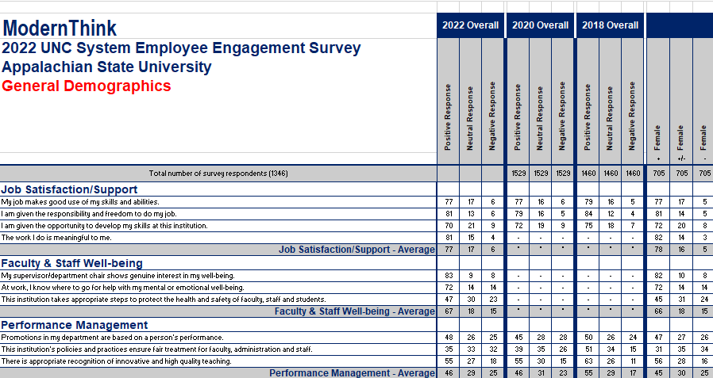

Job Role Spreadsheets

Like the General Demographics spreadsheets, the first nine columns of data on your Job Role Spreadsheets will contain the 2022, 2020, and 2018 overall positive/neutral/negative responses from your employees. This data is followed by seven benchmarks for comparison. The subsequent columns are stratified by demographic choices related to job role, including:

- Pre-loaded UNC Job Category
- Pre-loaded Job Role
- Faculty Appointment (Faculty Only)
- Tenure Status (Faculty Only)
- Years in Current Job Position

The spreadsheets are organized so that demographics like Pre-loaded Job Role, Faculty Appointment, etc. are located near the job categories to which they correspond to help facilitate analysis.

UNC  JOB CATEGORIES | JOB ROLE
SAAO Tier 1;  SAAO Tier 2 | None
Faculty | - Faculty Appointment  - Tenure Status
EHRA IRPS;  SHRA Exempt | - IRPS  - Administrative/Managerial  - Engineering/Architecture  - Human Services  - Information/Education  - Information Technology  - Institutional Services  - Law Enforcement/Public Safety  - Medical/Health  - Natural Resources/Scientific  - Operations/Trades
SHRA Non-exempt | - IRPS  - Administrative/Managerial  - Engineering/Architecture  - Human Services  - Information/Education  - Information Technology  - Institutional Services  - Law Enforcement/Public Safety  - Medical/Health  - Natural Resources/Scientific  - Operations/Trades

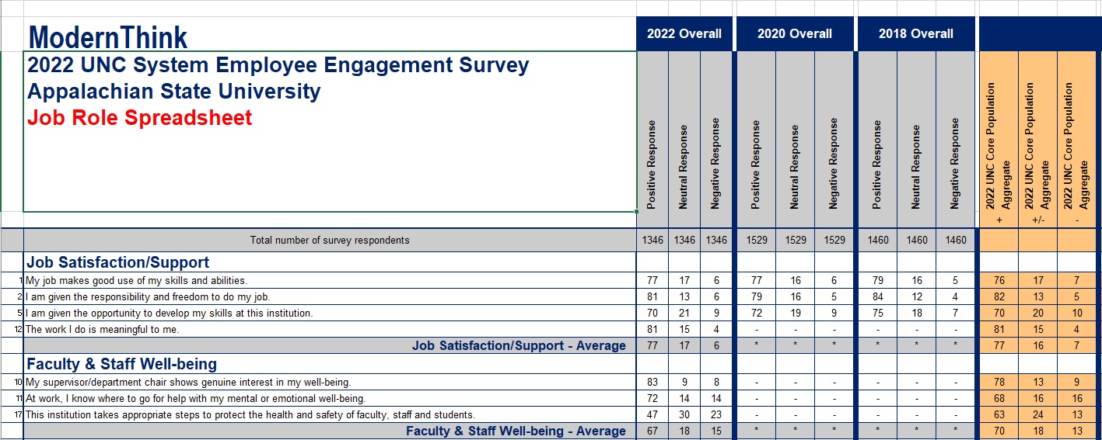

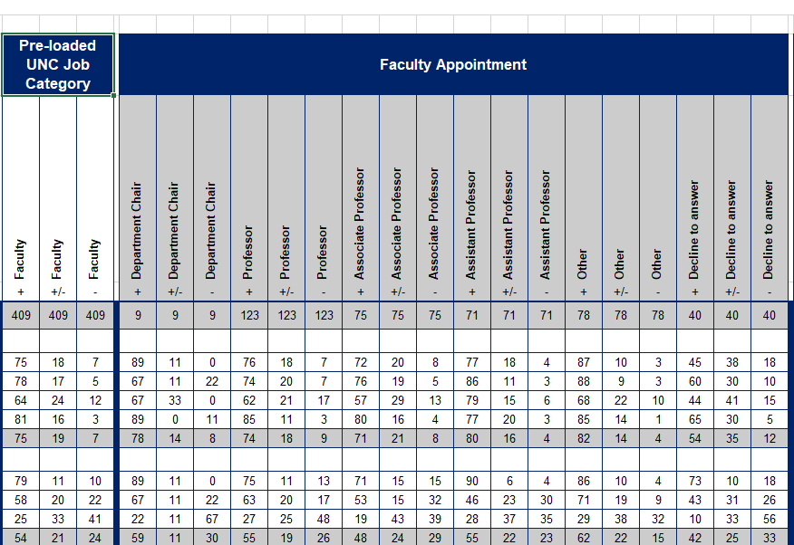

Organizational Level Spreadsheets

The remaining reports in the “Survey Data Spreadsheets” folder in your Results Suite file are your Organizational Level Spreadsheets. Most campuses will find a combination of spreadsheets containing two and three tiers of data as their organizational structures contain varying tiers in varying areas of their campuses. In some cases, multiple folders have been used to organize your data so that you can quickly and easily locate specific areas of your organizational structure. For example, you might have a folder that groups together all your “School/College” data, and a separate folder that contains all your “Area/Division” data.

Your Organizational Level spreadsheets have the same benchmarking as your Job Role spreadsheets, but they show only the percent positive data. The data in these are oriented to correspond with the organizational levels/structure provided to ModernThink for your survey demographics. In the sections of your organizational structure where there are only two tiers/levels, your level two demographics (generally departments) will be located next to the first level of demographics (generally colleges/schools or divisions), much like your job roles are situated next to your job categories on your Job Role Spreadsheets.

*The above image is a sample and does not reflect your institution’s actual survey data.

For the sections of your organizational structure where there are three tiers/levels you will find whole spreadsheets filtered by the first tier, with the second and third tiers displaying in accordance with the above screen shot. Filtering by a demographic means that only the organizational levels wholly contained within the filtered level will display on the spreadsheet. If a spreadsheet is filtered, that filtered demographic will always be in the file name of the spreadsheet. All spreadsheets containing data for just two tiers will be called “Organizational Level.”

A key distinction between these two versions of the organizational level spreadsheets is the data shown in the overall columns. In the first instance, where we are reporting only two levels of data, the overall columns will reflect your institution’s overall percent positive and percent negative data. These will sometimes be grouped in a folder labeled “CAMPUS Overall Data.” In the second instance, where we are reporting three tiers of data, and the spreadsheet is filtered by the first tier, the overall column of data will reflect the overall percent positive and negative data for the filtered demographic. These will sometimes be grouped in a folder labeled “FILTERED Overall Data.”

The sample organizational level spreadsheet below was filtered by “Academic Affairs,” so the overall columns of data show the overall percent positive and overall percent negative data for Academic Affairs. For example, 33% of those who selected “Academic Affairs” as their organizational division on the survey responded with either “Agree” or “Strongly Agree” to Statement 4: “I am provided the resources I need to be effective in my job.”

*The above image is a sample and does not reflect your institution’s actual survey data.

Because there is so much data to report in the organizational level spreadsheets, and ModernThink does not report data for demographic areas where there are fewer than five respondents, we have suppressed columns of demographics where there were not enough respondents to report the data. Please see your Profile of Survey Respondents (described in the next section) to identify which tiers contained demographic areas with fewer than five respondents.

Profile of Survey Respondents

This report shows your overall response rate and the profile of the respondents across your pre-loaded and self-selected demographic categories. You can use this report as a quick reference guide to see the number and percentage of respondents for each of your demographic choices, including Age, Pre-loaded UNC Job Category, Pre-loaded Employee Appointment Period, etc. Demographics that were pre-loaded, meaning the email addresses for your campus were tagged with this information before the survey was administered, are clearly labeled; all other demographics were self-selected, or voluntarily chosen by respondents while they were taking the survey.

Note that the “Demographic Category” column represents demographic questions while the “Response Options” column represents demographic choices. In many cases, the same terms are used in both. For example, a pre-loaded question on your survey might be, “Pre-loaded Org Level 1” with “Provost” as one of the response options. A subsequent question might then be, “Pre-loaded Org Level 2 – Provost.” The former example will show under “Response Options” as “Provost” with one n-value, representing the number of respondents who had “Provost” pre-loaded as their Org Level 1. The latter will show under “Demographic Category” as “Pre-loaded Org Level 2 - Provost”, with the Org Level 3 choices encompassed within it listed in the “Response Options” column next to it.

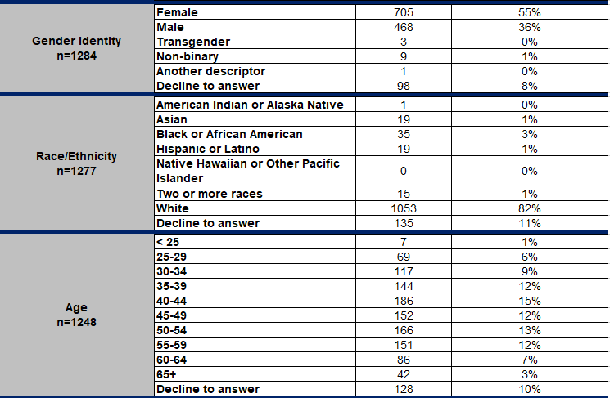

Response Distribution Report

As previously noted, your faculty and staff responded to each statement in the survey using a five-point agreement scale (Strongly Agree, Agree, Sometimes Agree/Sometimes Disagree, Disagree, Strongly Disagree, and Not Applicable). In the Response Distribution Report, you will find the percentages of all possible response options for each survey statement. You can compare your overall results to those within each of your Pre-loaded Employee Group 20 options.

Please note, the number ranging between 1 and 5 provided next to the number of respondents for each demographic subset represents the average with each response on the Likert Scale assigned a numerical weight:

Likert Scale Response | Numerical Weight
Strongly Agree | 5
Agree | 4
Sometimes Agree/Sometimes Disagree | 3
Disagree | 2
Strongly Disagree | 1

Thus the 3.69 provided in the example below would represent an average response of partway between Agree (4) and Sometimes Agree/Sometimes Disagree (3) for those tagged “SHRA” as their Pre-loaded Employee Group 20.

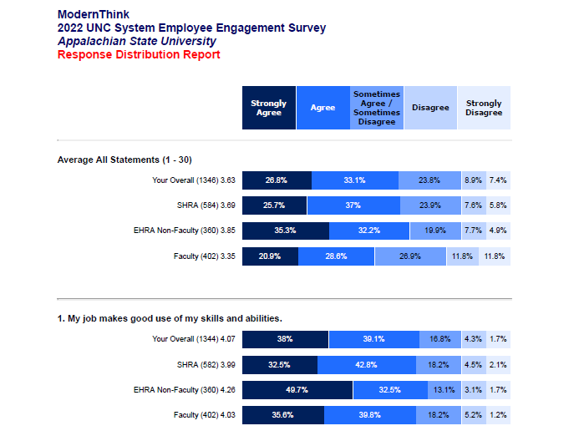
*Bars in the above graph may not be an exact proportion to the percentages they represent.

Overall Benchmark ScoreCard

The Overall Benchmark Scorecard compares the responses from your faculty and staff across the survey against a series of higher education benchmarks selected by the System Office:

- 2022 NC Core Population Aggregate
- 2020 NC Core Population Aggregate
- 2018 UNC Core Population Aggregate
- Carnegie Classification (specific to your institution)
- 4-Year Public Institutions
- 4-Year in your Enrollment Size (specific to your institution)
- 4-Year institutions in the Southeast Region

Results in the first column reflect your school's average percent positive for each survey statement, that is, the percentage of your faculty/staff who responded with “Strongly Agree” or “Agree.” Results in the second column reflect your school's average percent negative for each survey statement, that is, the percentage of your faculty/staff who responded with “Disagree” or “Strongly Disagree.”

All benchmarks contain 2022 data, except the 2020/2018 UNC Core Population Aggregate. Each benchmark comprises the average percent positive responses of those institutions from the ModernThink database that share that defining attribute. For example, your Southeast Region benchmark contains all 2022 Great Colleges participants located in the southeast.

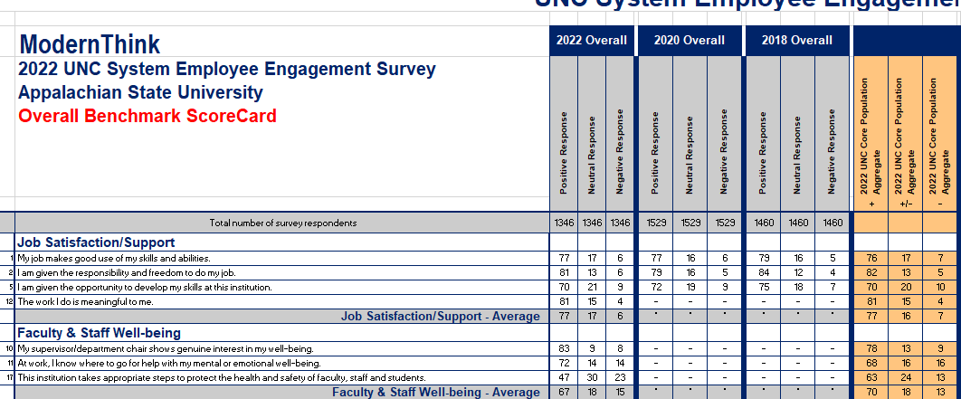

Multi-Select Report

Your faculty and staff were asked one multi-select question on your engagement survey:

Which of the following job opportunities would influence you the most to leave your current position (either to a position within the state system or to a position outside the state system)? Please select up to four responses.

This report shows the number and percentage of responses for each question choice, ranked from most to least frequently selected.

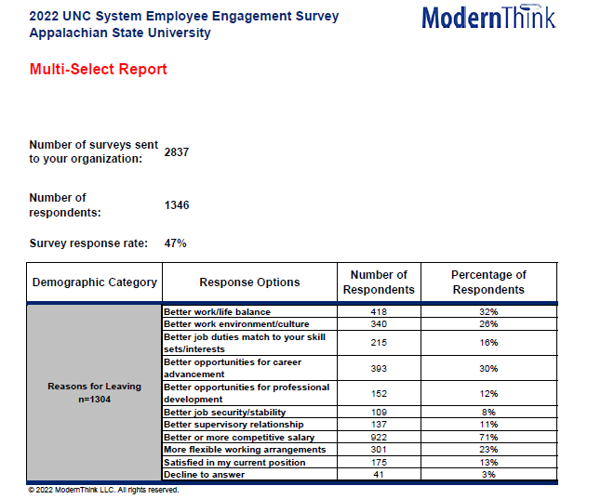

Topline Survey Results

Your Topline Survey Results report shows your results for each of the survey dimensions that characterize the ModernThink Higher Education Insight Survey©. In addition to your overall scores, data is broken down by EHRA Non-faculty (NF), Faculty, and SHRA. There is also a column for “Other” staff who do not fit into one of the above categories. This column will only populate for campuses that included CSS Exempt, COS Non-exempt, or CSS Non-exempt Staff, or Adjunct Faculty. The numbers shown represent percent positive responses, or the percentage of respondents who selected “Strongly Agree” or “Agree.”

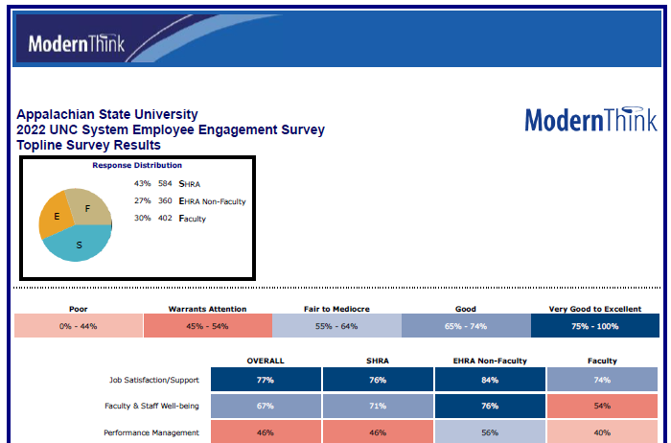

Employee Comments Report

The Employee Comments Report conveys the experiences of your employees, provided by the employees themselves. When your faculty, administration and staff completed the 2022 UNC System Employee Engagement Survey they were asked two open-ended questions:

What do you appreciate most about working at this institution?
What would make this institution a better place to work?

Responses to these two questions are detailed in this report. To encourage honest, candid feedback and protect the anonymity of individual respondents, we advised employees not to include any self-identifying information. Additionally, comments have been suppressed for Pre-loaded UNC Job Categories with fewer than five respondents. We have presented the comments exactly as they were provided to us, ordered alphabetically by first letter to help preserve anonymity.

Additional Reports

If you are interested in diving deeper into your data, or require support for presenting results to your Board or other key stakeholder groups, please contact Suzi Schmittlein at 888.684.4658 or via email at sschmittlein@modernthink.com. ModernThink has a number of additional reports and consulting services available, including, but not limited to, the following:

Report/Consulting Service | Price
Online Report Gateway (includes all of your institution’s survey results and benchmarking: 2022, 2020, 2018); Access for up to 10 users (all data) | $5,000
Report Gateway Renewal | $2,900
60-Minute Phone Consultation (SWOT Style) | $900
Webinar Presentation (up to 2 hours) includes PowerPoint | $2,150
Onsite Consultation/Presentations (full day) includes PowerPoint | $5,195 + expenses
Onsite Consultation/Presentations (half day) includes PowerPoint | $3, 870 + expenses

Further Assistance and Next Steps

Please contact Liz Flood with any comments or questions about your Results Suite, or if we can be of any further assistance. Liz can be reached at 888.684.4658 or via email at lflood@modernthink.com.

